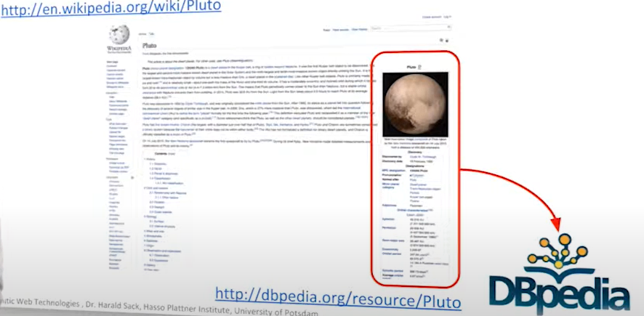

Infobox: contain structured data that can be easily extracted and can be transcoded to form a semantic representation of this entity pluto

dbpedia (almost) cover all the infobox available on wikipedia

RDF: all knowledge is expressed in RDF triples

SPARQL query language for RDF encoded data, we can make query and try to answer complex question

